As a planet, we entered the “space age” decades ago. Still, ask any classroom of children their dream profession and you’re likely to hear “astronaut” from more than one child.

Then, why have we seemingly stopped writing about outer space? In an analysis of book publications regarding outer space, 1961 stands tall as the year for space-related literature. The topic has seen little movement since the 1980s, when it saw a fairly notable rise in publications once again.

The topic can be traced back to the early 1800s, where publications were first and foremost scientific in nature and targeted towards academia.

In the 1960s, many publications attempted to outline rules and guidelines for the exploration of outer space and navigating inter-national diplomacy in this arena. However, as early as the fir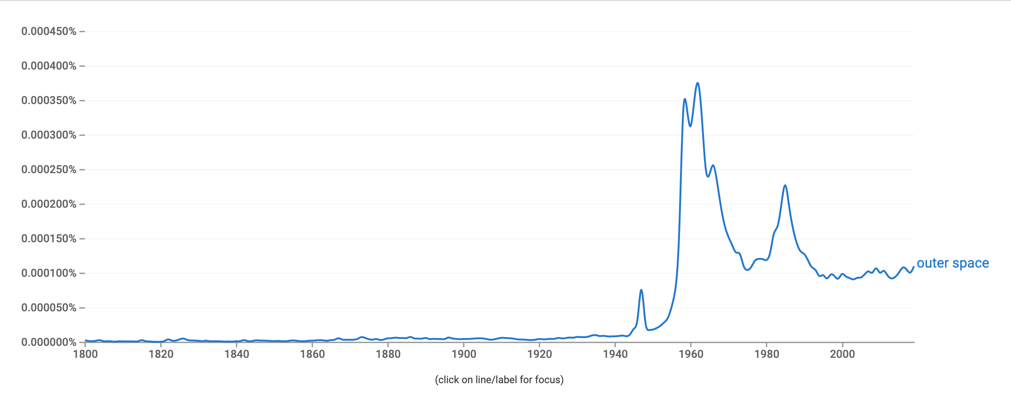st half of the 20th century, fantasy novels begin to appear discussing outer space, and see a consistent rise up through the first moon landing in 1968. Despite the sharp drop off in overall popularity, fantasy novels continued to claim a large segment of publications for decades.

After that, much of both academic and literary publications seem to decline in popularity, perhaps indicating both a decline in interest and a limit to the knowledge able to be sourced for public consumption.

Over the 21st century, publications regarding outer space have diminished in variety, but one genre remains strong: educational materials targeted to children.

So, while adults may have reached a wall in understanding, perhaps the imagination and enthusiasm of children has kept the fascination of outer space alive.